Natural gas crisis in Europe makes green chemicals win-win solutions
Abhinandan Nabera, Ioan-Robert Istrate, Javier Pérez-Ramírez and Gonzalo Guillén-Gosálbez*
Institute for Chemical and Bioengineering, Department of Chemistry and Applied Biosciences, ETH Zürich, Vladimir-Prelog-Weg 1, Zürich 8093, Switzerland
*Corresponding author: gonzalo.guillen.gosalbez@chem.ethz.ch

Context and scale
Text text text.

Summary
Text text text.

Introduction
The chemical industry is the industrial sector with the highest energy demand as it uses fossil fuels both as feedstock and fuel. About 14% and 8% of global oil and gas, respectively, are consumed by the chemical industry¹, which is also responsible for 5.6 Gt CO₂-eq per year (including direct and indirect emissions), equivalent to roughly 10% of global anthropogenic greenhouse gas (GHG) emissions^{2,3}. Out of all the chemicals, ammonia, methanol, ethylene, and propylene are the major building blocks of the chemical industry which are further used as raw materials for the production of valuable products. Notably, ammonia is critical to the production of fertilizers and to ensure global food security⁴, while methanol is largely used for the production of valuable products (e.g., formic acid, acetic acid, dimethyl ether, and methylamine) and can serve as an intermediate to olefins and aromatics⁵. Ammonia is predominantly produced via the Haber-Bosch process using natural gas as feedstock and is responsible for one-fourth of the total fossil fuel consumption in the chemical industry⁶. Similarly, methanol relies on natural gas or coal for the production of syngas which is then converted to methanol via the water-gas shift reaction.

Ammonia and methanol are two hard-to-abate chemicals primarily due to their strong dependence on natural gas as a feedstock. Hence, shifting to renewable feedstocks is paramount to mitigate their climate impacts^{7,8}. Low-carbon ammonia production is possible by replacing the steam methane reforming (SMR)-based hydrogen with electrolytic hydrogen powered by wind or solar energy⁹. Moreover, carbon capture and utilization (CCU) offers a route to decarbonize methanol production via CO₂ hydrogenation¹⁰. Prior works have demonstrated the technical feasibility¹¹ and potential climate benefits^{9,12–14} of green chemicals production routes, but the high costs remain a major barrier to their implementation¹⁵. Literature estimates suggest that green ammonia and methanol cost twice as much as the natural gas-based counterpart^{9,10}.
The economic viability of green chemicals has been largely hampered by the high costs of renewable feedstocks (i.e., hydrogen and captured CO₂) compared with natural gas^{9,10}. However, natural gas has seen a sharp increase in prices over the last two years, primarily due to the COVID-19 pandemic, skyrocketing inflation, and the global energy crisis caused by the Russian invasion of Ukraine. In Europe, which is particularly affected by the new geopolitical scenarios, monthly average natural gas spot prices have increased from 560 USD t⁻¹ in July 2021 to 2,300 USD t⁻¹ as of July 2022¹⁶. Similarly, the price of grid electricity has almost quadrupled [Ember]. The drastic increase in natural gas and electricity prices has severe consequences for the European chemical industry. For example, recent news suggest that more than half of the Europe’s ammonia production capacity (estimated at around 19 Mt year⁻¹)¹⁷ has been shut down due to gas prices^{18,19}.
The energy crisis in Europe can in principle help making green chemicals more economically appealing while laying the foundation for a renewable transition in the European chemical industry. However, whether green chemicals represent win-win solutions (understood as a Pareto improvement²⁰: simultaneous reduction of costs and GHG emissions) in the present state of affairs has not been explored yet. In this work, we calculate the production and CO₂ avoidance costs for fossil and green ammonia and methanol in Europe considering the impact of natural gas price fluctuation.

Results

Cost comparison between the fossil and green routes of production
Considering the natural gas spot price in Europe as of September 2022, we estimate the production cost for fossil ammonia at around 1,965 USD t⁻¹, which is three times higher in comparison to July 2021. When natural gas prices reach around 1,400 USD t⁻¹ (September 2021), green ammonia produced with hydrogen from water electrolysis using on-shore wind electricity turns cost-competitive with fossil ammonia (Fig. 1a). Based on monthly average natural gas spot prices, ammonia production via wind electrolysis has been cheaper than or similar to fossil ammonia for seven months since October 2021. Whereas, green ammonia produced via solar-based electrolytic hydrogen is only feasible around the peak of natural gas prices in August 2022 (Fig. 1b). This can be attributed to lower capacity factors (16.1% to 17.5%) in comparison to wind electricity (35.6% to 39%) resulting in higher levelized costs of hydrogen²¹. Ammonia production with blue hydrogen −SMR coupled with carbon capture and storage (CCS)− is always more expensive than the conventional route due to the additional cost of CCS and extra nitrogen feed (Fig. 1c).
Similar to ammonia, the cost of production for fossil methanol has increased sharply. In comparison to July 2021, the estimated production cost for fossil methanol rose by 232% in September 2022, reaching XXX USD t⁻¹. At natural gas prices of around 2,475 USD t⁻¹, green methanol produced with wind-based hydrogen is economically competitive (Fig. 1d). However, the break-even natural gas price largely depends on the levelized cost of hydrogen, and could decrease to 1,700 USD t⁻¹ if considering the low-end of hydrogen cost range. The solar-based route follows a similar trend to that seen for ammonia and is only feasible at the peak of natural gas prices (August 2022) and the low-end of the hydrogen cost range (Fig. 1e). For the case of blue hydrogen from SMR + CCS, the cost of production is on average 68% higher than conventional methanol due to the additional cost of CCS and captured CO₂.
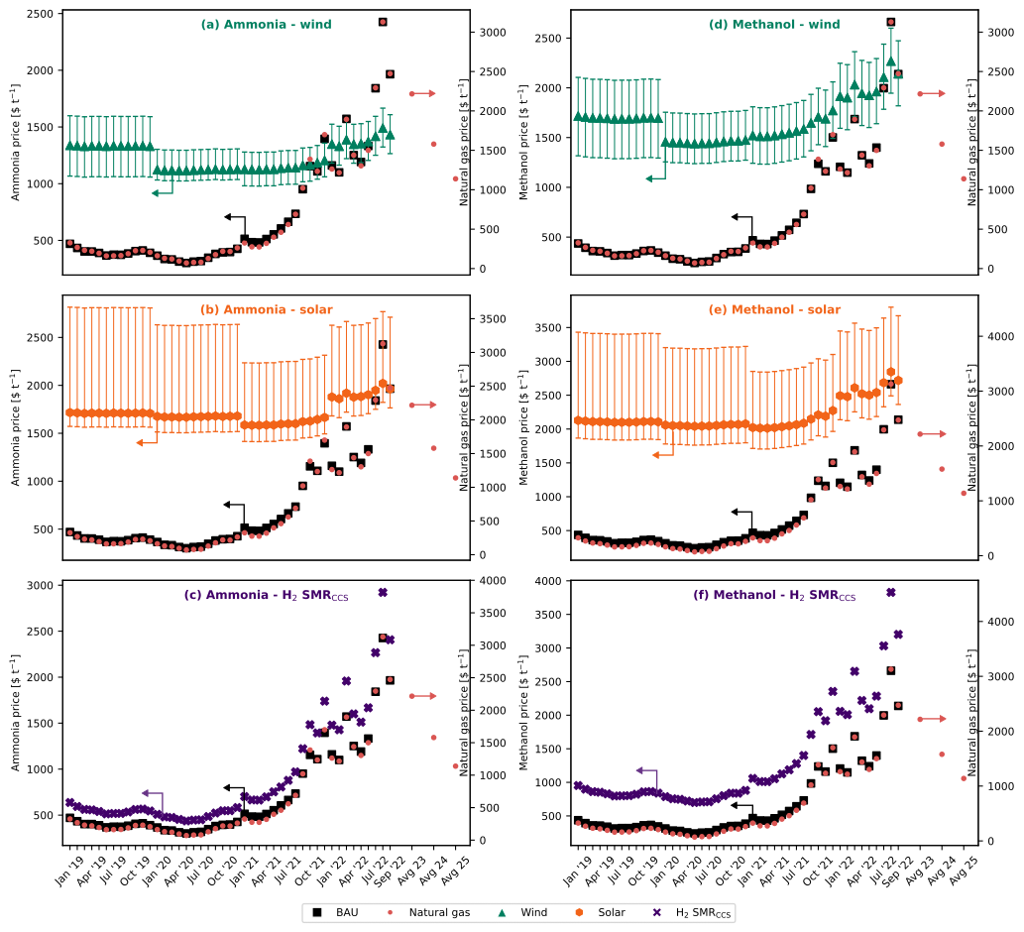
Fig. 1. Evolution of the production cost for fossil and green ammonia and methanol under the European spot price for natural gas. The error bars display the production cost considering the lower and upper bound for the levelized cost of hydrogen²¹.

To investigate further, Fig. 2 shows the breakdown of the production costs for fossil chemicals and wind-based green routes at different time points. We take average values for the years 2019 and 2020 as the natural gas and electricity prices before July 2021 were approximately constant (Supplementary table xx). Notably, the contribution of natural gas to the average production costs for fossil ammonia increased from 22% in 2020 to 44% in July 2021 and up to 66% in September 2022 (Fig. 2a). Similarly, the contribution of electricity increased from 8% in 2020 to 17% in September 2022. Green hydrogen from wind electrolysis has the highest share (67% to 83%) of the production cost for green ammonia. Since wind electricity is used only for the electrolyzer, whereas for the compressors we consider grid electricity, the share of grid electricity rose from ∼1% in 2020 to 11% in September 2022.
Similarly, for the production of fossil methanol, the share of natural gas increased from 32% in 2020 to 58% in July 2021 and 77% in September 2022 (Fig. 2b). Whereas, the contribution of electricity increased from 7% in 2020 to 12% in September 2022. Hydrogen from wind electrolysis had the highest share of around 60% in July 2021 which decreased to 51% in September 2022 for the green methanol production route. The share of CO₂ from DAC was about 17% in 2020 and increased to 33% in September 2022. This increase can be attributed to the increase in natural gas prices which is required for the capture of CO₂ via DAC.
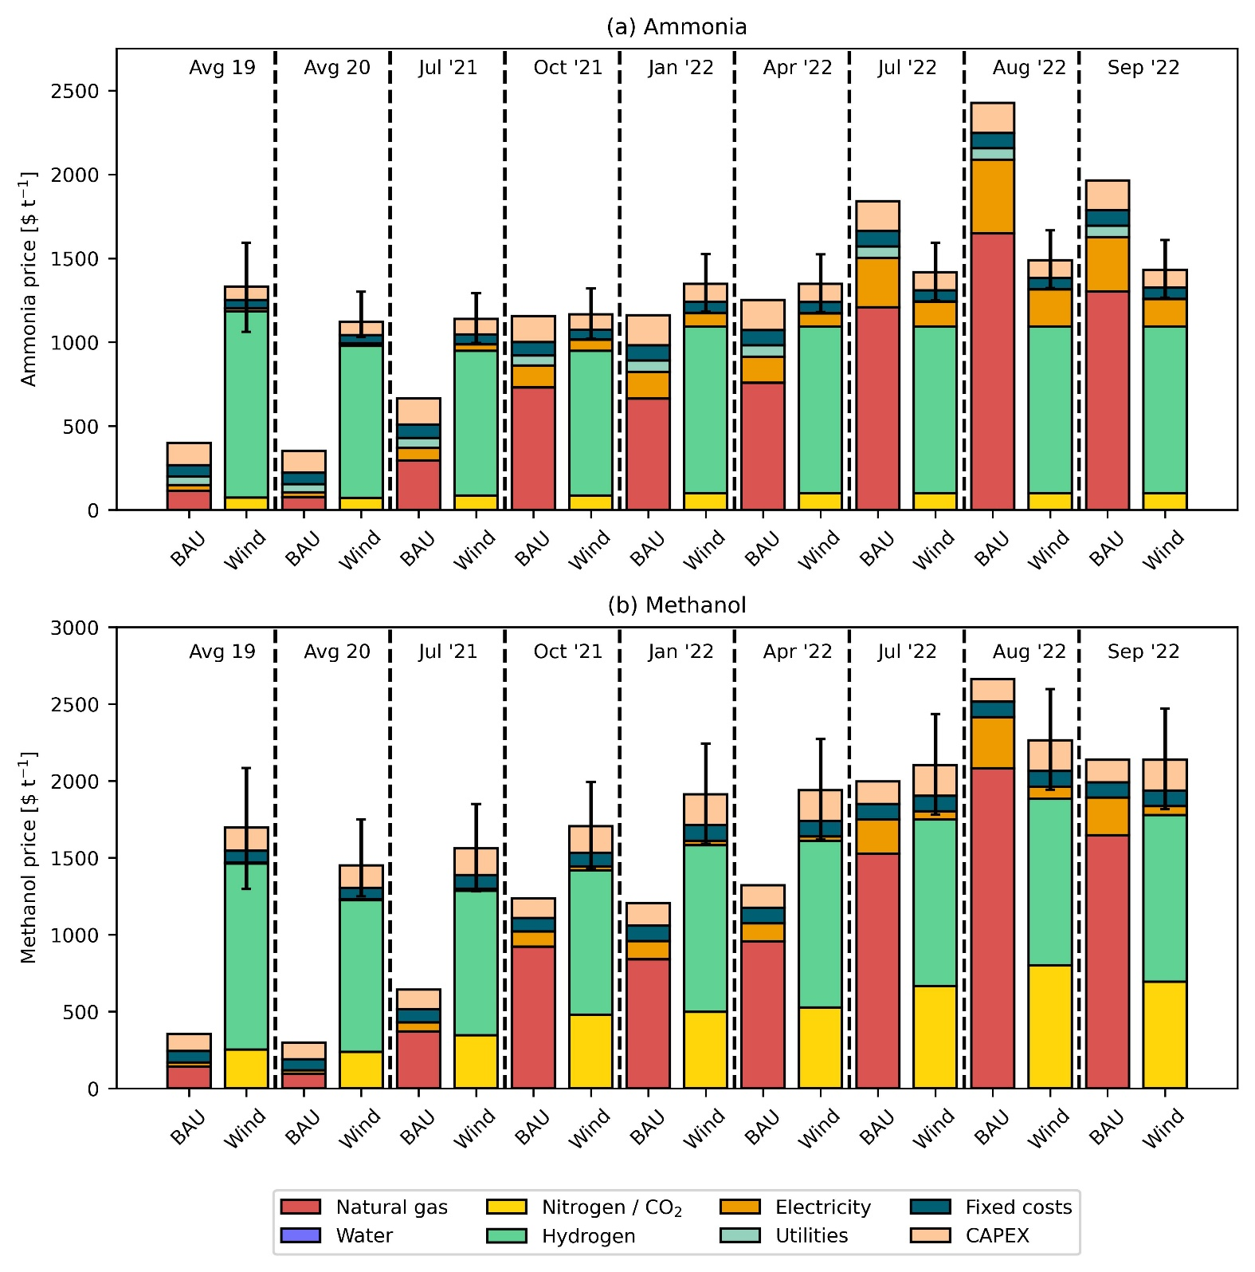
Fig. 2. Breakdown of production costs for fossil and green ammonia (a) and methanol (b). The green route uses hydrogen from water electrolysis using on-shore wind electricity and CO₂ from direct air capture (DAC). The error bars display the production cost considering the lower and upper bound for the levelized cost of hydrogen²¹.

CO₂ avoidance cost
The CO₂ avoidance cost follows an inverse trend to the natural gas price (Fig. 3). In 2020 at an average natural gas price of XXX USD t⁻¹, wind- and solar-based ammonia result in an avoidance cost of XXX and XXX USD t⁻¹ CO₂, respectively. This cost is substantially higher for methanol with XXX and XXX USD t⁻¹ CO₂, respectively, primarily due to XXXX. Notably, the avoidance cost of green ammonia and methanol in 2020 largely surpasses the removal cost of bioenergy with carbon capture and storage (CCS) and DAC with carbon capture and storage (DACCS), forecasted at 100-200 USD t⁻¹ CO₂ and 100-300 USD t⁻¹ CO₂, respectively²². However, as natural gas prices increase, less money is required for every ton of CO₂ emission avoided by switching from fossil to green chemicals. At the peak of natural gas prices in 2022, the avoidance cost of green ammonia and methanol becomes negative, meaning that the industry could simultaneously reduce costs and CO₂ emissions. Since July 2021, the industry could save around 125 to 638 USD t⁻¹ CO₂ avoided via the wind route for ammonia production. Similarly, in August 2022 for methanol via wind, savings stood at around 325 USD t⁻¹ CO₂ avoided.
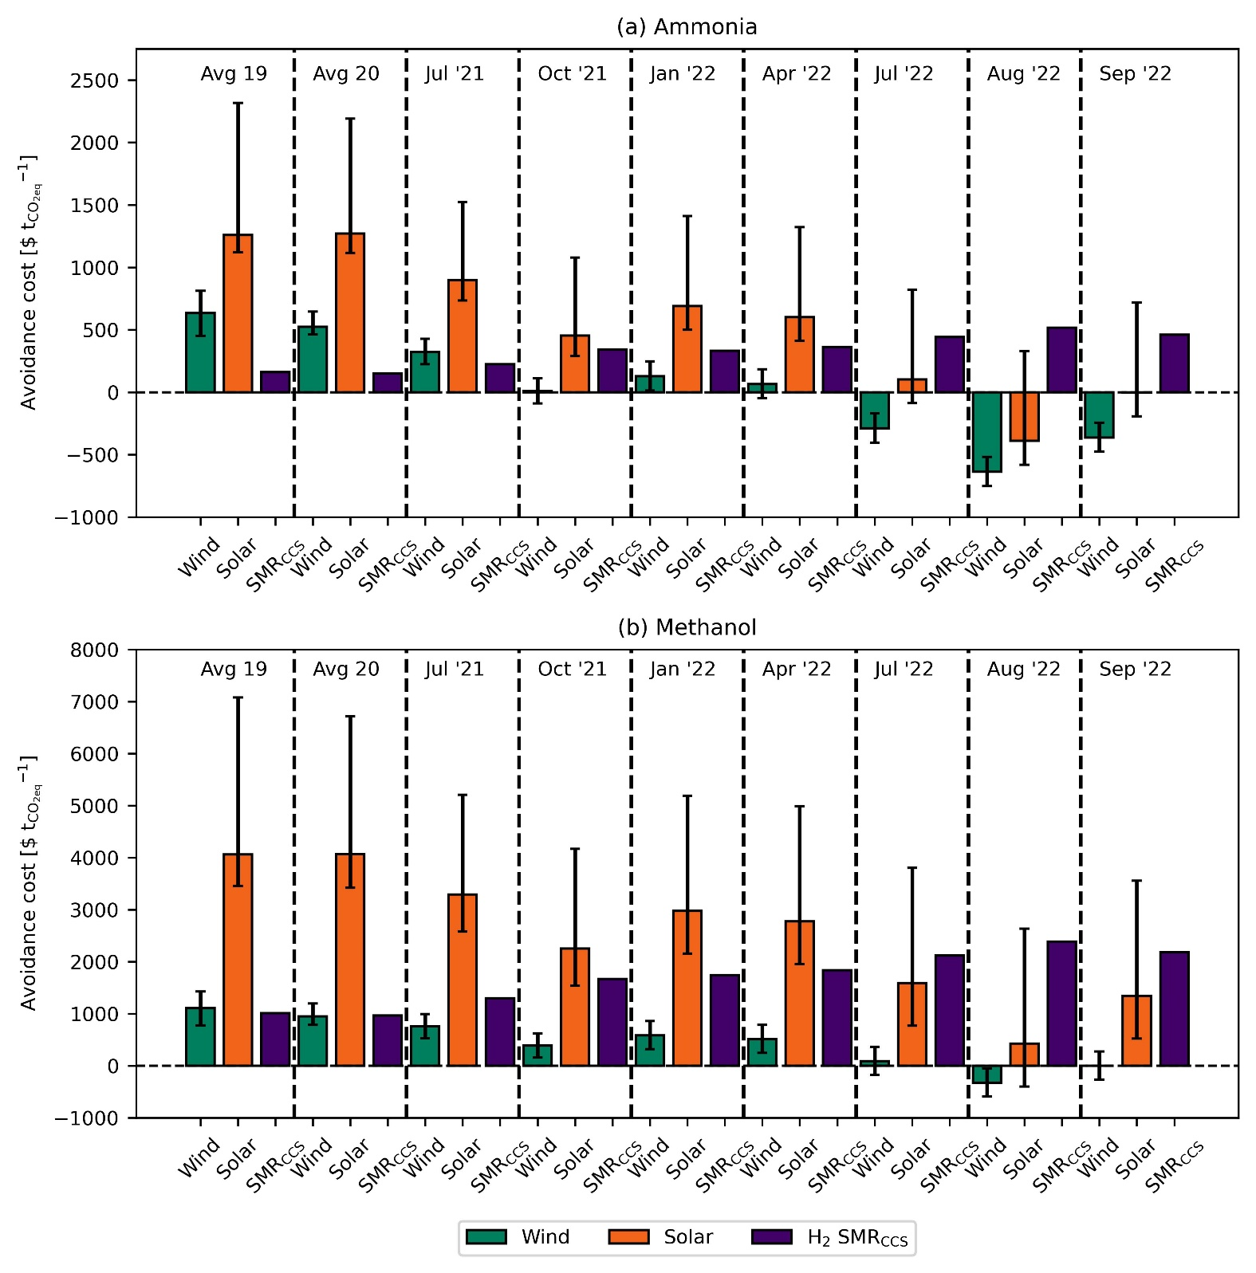
Fig. 3. CO₂ avoidance costs for green ammonia (a) and methanol (b). The error bars display the production cost considering the lower and upper bound for the levelized cost of hydrogen²¹.

Discussion
While the current energy crisis faced in Europe is exceptional, natural gas prices are predicted to remain high (1,579 – 2,216 USD t⁻¹) for the next few years. On the contrary, the costs of renewable energy technologies are expected to decrease²³. For that reason, ammonia production from wind could be the most promising technology in the foreseeable future. Identical to the case of ammonia, methanol production via wind is expected to be cost-competitive with fossil methanol in the coming future.

Experimental procedures
Scenarios definition. Three alternative routes for the production of ammonia are considered. The only difference in these three cases is the source of hydrogen. The different sources of hydrogen considered are water electrolysis using on-shore wind electricity, water electrolysis using solar electricity, and SMR + CCS. For all the alternatives, along with hydrogen, nitrogen from cryogenic air separation is used as a feedstock. Whereas, in the case of conventional ammonia, nitrogen comes from the air which is used in the autothermal reactor⁹. Following an identical approach to ammonia, three alternative routes for methanol production are considered depending on the source of hydrogen. They are water electrolysis using on-shore wind electricity, water electrolysis using solar electricity, and SMR + CCS. In the fossil route, natural gas is first converted to syngas and then to methanol using the water gas shift reaction. Every ton of conventional methanol produced consumes 0.67 tons of natural gas and 708 kWh of electricity. In the alternative routes of methanol production, for every ton of carbon dioxide captured, 0.11 tons of natural gas is required. All three alternative routes of production use CO₂ from direct air capture (DAC) as a feedstock. Therefore, carbon dioxide and hydrogen undergo the reverse water gas shift reaction to produce syngas, and syngas is converted to methanol in the next step.
Economic assessment. The material balances and energy flows for both fossil and green ammonia are extracted from the work done by D’Angelo et al.⁹. In the case of fossil ammonia, every ton of ammonia produced consumes 0.53 tons of natural gas and 940 kWh of electricity. The material balance and energy flows for BAU methanol and green methanol are extracted from L.A. Pellegrini et al. 2011 and Vázquez et al. 2021, respectively. Monthly average natural gas and electricity prices in Europe are shown in table xx.
CO₂ avoidance costs. The CO₂ avoidance costs in $ t⁻¹_{CO2eq} are calculated as follows:
$${\text{CO}}_{\text{2}}\text{ avoidance costs [}\frac{\text{\$}}{{\text{t}}_{{\text{CO}}_{\text{2eq}}}^{\text{-1}}}\text{] =} \frac{{\text{P.C}}_{\text{ALT}}\text{ -} {\text{P.C}}_{\text{BAU}}}{{\text{GWP}}_{\text{BAU}}\text{ -} {\text{GWP}}_{\text{ALT}}}$$
where P.C_{BAU/ALT} represents the production cost in $ t⁻¹ for the conventional (BAU) and alternative (ALT) routes. Similarly, GWP_{BAU/ALT} represents the global warming potential in t_{CO2eq} t⁻¹ for the conventional (BAU) and alternative (ALT) routes of production.

References
1. IEA (2018). The Future of Petrochemicals: Towards more sustainable plastics and fertilisers (International Energy Agency).
2. Bauer, F., Tilsted, J.P., Pfister, S., Oberschelp, C., and Kulionis, V. (2023). Mapping GHG emissions and prospects for renewable energy in the chemical industry. Current Opinion in Chemical Engineering 39, 100881. 10.1016/j.coche.2022.100881.
3. Bauer, F., Kulionis, V., Oberschelp, C., Pfister, S., Tilsted, J.P., Finkill, G.D., and Fjäll, S. (2022). Petrochemicals and Climate Change: Tracing Globally Growing Emissions and Key Blind Spots in a Fossil-Based Industry (Lund University).
4. Erisman, J.W., Sutton, M.A., Galloway, J., Klimont, Z., and Winiwarter, W. (2008). How a century of ammonia synthesis changed the world. Nature Geosci 1, 636–639. 10.1038/ngeo325.
5. Olah, G.A. (2005). Beyond Oil and Gas: The Methanol Economy. Angewandte Chemie International Edition 44, 2636–2639. 10.1002/anie.200462121.
6. Levi, P.G., and Cullen, J.M. (2018). Mapping Global Flows of Chemicals: From Fossil Fuel Feedstocks to Chemical Products. Environ. Sci. Technol. 52, 1725–1734. 10.1021/acs.est.7b04573.
7. Lange, J.-P. (2021). Towards circular carbo-chemicals – the metamorphosis of petrochemicals. Energy Environ. Sci. 14, 4358–4376. 10.1039/D1EE00532D.
8. Schiffer, Z.J., and Manthiram, K. (2017). Electrification and Decarbonization of the Chemical Industry. Joule 1, 10–14. 10.1016/j.joule.2017.07.008.
9. D’Angelo, S.C., Cobo, S., Tulus, V., Nabera, A., Martín, A.J., Pérez-Ramírez, J., and Guillén-Gosálbez, G. (2021). Planetary Boundaries Analysis of Low-Carbon Ammonia Production Routes. ACS Sustainable Chem. Eng. 9, 9740–9749. 10.1021/acssuschemeng.1c01915.
10. González-Garay, A., Frei, M.S., Al-Qahtani, A., Mondelli, C., Guillén-Gosálbez, G., and Pérez-Ramírez, J. (2019). Plant-to-planet analysis of CO₂ -based methanol processes. Energy Environ. Sci. 12, 3425–3436. 10.1039/C9EE01673B.
11. IEA (2013). Technology Roadmap Energy and GHG Reductions in the Chemical Industry via Catalytic Processes (International Energy Agency).
12. Galán-Martín, Á., Tulus, V., Díaz, I., Pozo, C., Pérez-Ramírez, J., and Guillén-Gosálbez, G. (2021). Sustainability footprints of a renewable carbon transition for the petrochemical sector within planetary boundaries. One Earth 4, 565–583. 10.1016/j.oneear.2021.04.001.
13. Ioannou, I., Galán-Martín, Á., Pérez-Ramírez, J., and Guillén-Gosálbez, G. (2022). Trade-offs between Sustainable Development Goals in carbon capture and utilisation. Energy Environ. Sci. 10.1039/D2EE01153K.
14. Kätelhön, A., Meys, R., Deutz, S., Suh, S., and Bardow, A. (2019). Climate change mitigation potential of carbon capture and utilization in the chemical industry. Proceedings of the National Academy of Sciences 116, 11187–11194. 10.1073/pnas.1821029116.
15. Hepburn, C., Adlen, E., Beddington, J., Carter, E.A., Fuss, S., Mac Dowell, N., Minx, J.C., Smith, P., and Williams, C.K. (2019). The technological and economic prospects for CO2 utilization and removal. Nature 575, 87–97. 10.1038/s41586-019-1681-6.
16. The World Bank (2022). Commodity Markets Outlook: The Impact of the War in Ukraine on Commodity Markets (The World Bank Group).
17. Ausfelder, F., Herrman, E.O., and López González, L.F. (2022). Technology options for CO2-emission reduction of hydrogen feedstock in ammonia production (DECHEMA Gesellschaft für Chemische Technik und Biotechnologie e.V).
18. de Sousa, A., Gebre, S., and Treloar, S. (2022). Europe’s Widening Fertilizer Crisis Threatens Food Supplies. Bloomberg.com.
19. Lopez, J. (2022). EPCA ’22: European shut ammonia production unlikely to return - analyst. ICIS Explore. https://www.icis.com/explore/resources/news/2022/10/04/10811649/epca-22-european-shut-ammonia-production-unlikely-to-return-analyst.
20. Hegwood, M., Langendorf, R.E., and Burgess, M.G. (2022). Why win–wins are rare in complex environmental management. Nat Sustain 5, 674–680. 10.1038/s41893-022-00866-z.
21. IRENA (2021). Making the breakthrough: Green hydrogen policies and technology costs (International Renewable Energy Agency).
22. Fuss, S., Lamb, W.F., Callaghan, M.W., Hilaire, J., Creutzig, F., Amann, T., Beringer, T., Garcia, W. de O., Hartmann, J., Khanna, T., et al. (2018). Negative emissions—Part 2: Costs, potentials and side effects. Environ. Res. Lett. 13, 063002. 10.1088/1748-9326/aabf9f.
23. Way, R., Ives, M.C., Mealy, P., and Farmer, J.D. (2022). Empirically grounded technology forecasts and the energy transition. Joule 6, 2057–2082. 10.1016/j.joule.2022.08.009.

